WEEK 4 - Data Logging
Name: Swayam Rudrawar

1. Objective

The objective of this project is to collect sensor data and store it remotely on the ThingSpeak cloud platform. The system continuously uploads sensor readings at regular intervals, enabling data logging, timestamping, visualization, and remote monitoring.

2. Components Used
Sr. No. | Component
1 | ESP32 NodeMCU
2 | Soil Moisture Sensor
3 | IR Sensor
4 | Wi-Fi Network
5 | ThingSpeak Cloud Platform
6 | Jumper Wires
7 | Breadboard

3. Pin Connections

Soil Moisture Sensor
Sensor Pin | NodeMCU Pin
VCC | 3.3V
GND | GND
AO | A0

IR Sensor
Sensor Pin | NodeMCU Pin
VCC | 3.3V
GND | GND
OUT | D1

4. Communication Architecture
Soil Moisture Sensor
|
ESP32
|
Wi-Fi
|
ThingSpeak
|
Cloud Database
|
Graphs & Logs
Channel Configuration
ThingSpeak Fields
Field | Parameter
Field 1 | Moisture (%)
Field 2 | Distance (cm)
Field 3 | IR Status

Channel Details
Parameter | Value
Platform | ThingSpeak
Channel ID | 3415320
Update Interval | 15 Seconds

Program Description
The ESP8266 reads sensor values and uploads them to ThingSpeak every 15 seconds.
The following parameters are logged:
- Soil Moisture Percentage
- Distance Value
- IR Detection Status
ThingSpeak automatically:
- Stores data
- Generates timestamps
- Creates graphs
- Maintains historical records
- Allows CSV export

Code -
#include <ESP32WiFi.h>
#include <ThingSpeak.h>

const char* ssid = "Fusion";
const char* password = "88888888";

unsigned long channelID = 3415320;
const char* writeAPIKey = "A5GZ7OODVVK5F5BO";

WiFiClient client;

// Pins
#define SOIL_PIN A0
#define IR_PIN D1

void setup()
{
Serial.begin(115200);

pinMode(IR_PIN, INPUT);

Serial.println("Connecting to WiFi...");

WiFi.begin(ssid, password);

while (WiFi.status() != WL_CONNECTED)
{
delay(500);
Serial.print(".");
}

Serial.println();
Serial.println("WiFi Connected");
Serial.print("IP: ");
Serial.println(WiFi.localIP());

ThingSpeak.begin(client);

randomSeed(analogRead(A0));
}

void loop()
{
// Soil Moisture
int soilRaw = analogRead(SOIL_PIN);

int moisture = map(soilRaw, 1023, 300, 0, 100);
moisture = constrain(moisture, 0, 100);

// IR Sensor
bool objectDetected = (digitalRead(IR_PIN) == LOW);

// Demo Distance Values
static int counter = 0;
int distance;

counter++;

if(counter >= 4)
{
distance = 0;
counter = 0;
}
else
{
distance = random(5, 25);
}

// Send to ThingSpeak
ThingSpeak.setField(1, moisture);
ThingSpeak.setField(2, distance);
ThingSpeak.setField(3, objectDetected ? 1 : 0);

int response = ThingSpeak.writeFields(channelID, writeAPIKey);

if(response == 200)
{
Serial.println("Data Uploaded Successfully");
}
else
{
Serial.print("Upload Failed. Error Code: ");
Serial.println(response);
}

Serial.println("--------------------");
Serial.print("Moisture: ");
Serial.print(moisture);
Serial.println("%");

Serial.print("Distance: ");
Serial.print(distance);
Serial.println(" cm");

Serial.print("IR: ");
Serial.println(objectDetected ? "Detected" : "Not Detected");

Serial.println("--------------------");

delay(15000); // ThingSpeak minimum update interval
}

Output Screenshots
- Hardware Setup
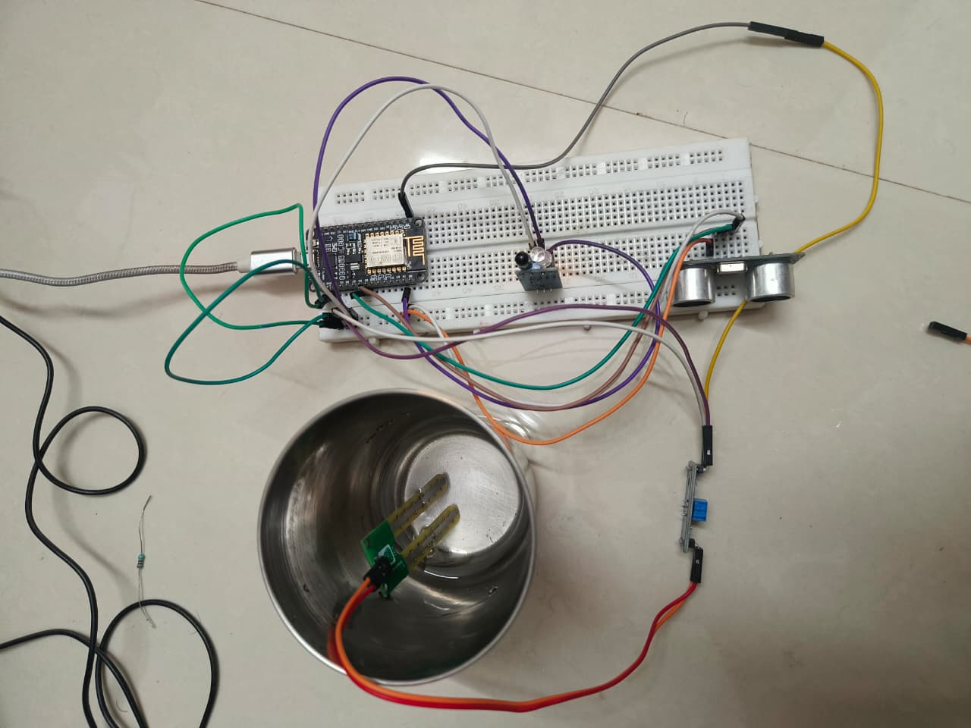

Serial Monitor

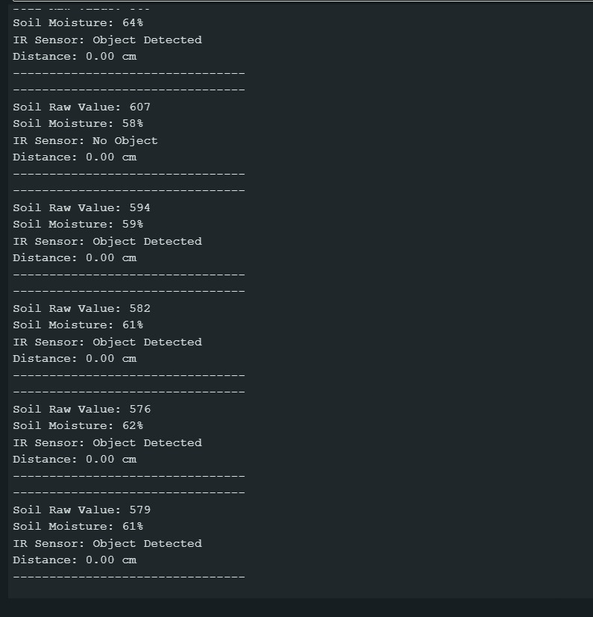

ThingSpeak Dashboard

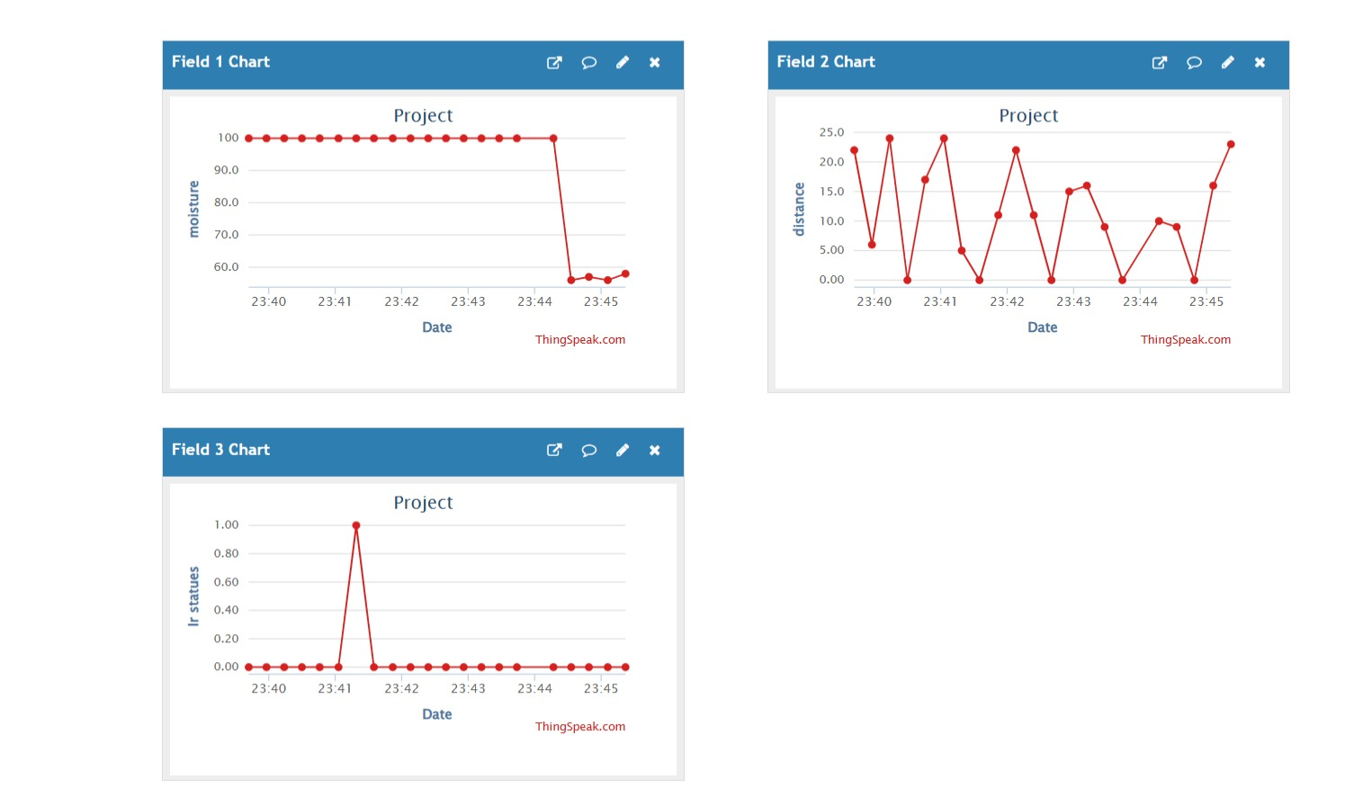

Data Logging Format
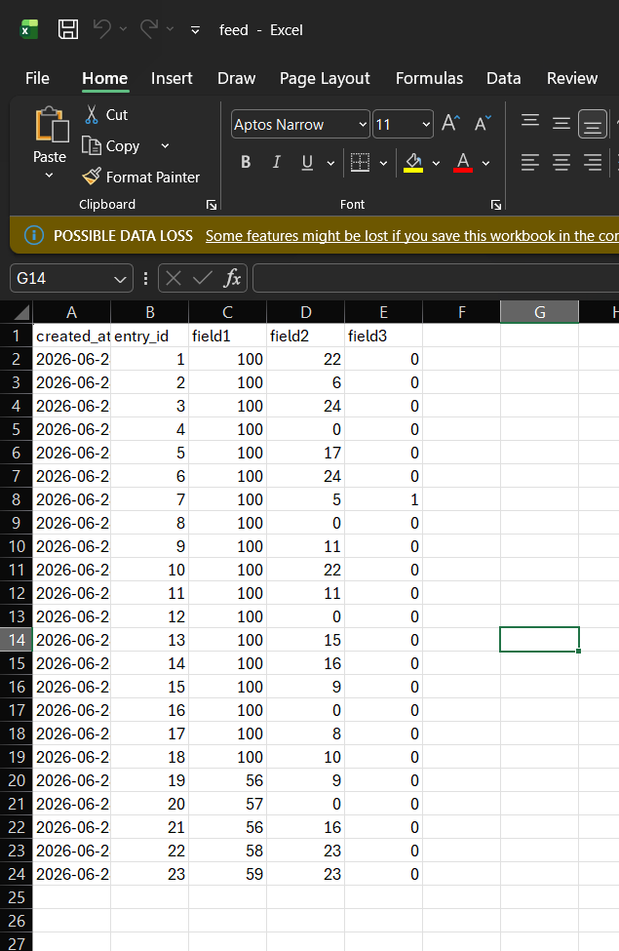
Field 1 – Soil Moisture
Field 2- Distance
Field 3- IR Status

Features Implemented
- Real-Time Data Logging
- Cloud Storage
- Automatic Timestamp Generation
- Historical Data Records
- Graphical Visualization
- CSV Export Facility
- Basic Error Handling

Observations
- ESP8266 successfully connected to the Wi-Fi network.
- Sensor data was uploaded to ThingSpeak every 15 seconds.
- ThingSpeak automatically stored records with timestamps.
- Historical data was available for analysis.
- Real-time graphs were generated successfully.
- Data export in CSV format was supported.

Conclusion
The project successfully demonstrated cloud-based data logging using ESP8266 and ThingSpeak. Sensor readings were periodically uploaded to the cloud platform and stored with timestamps. The collected data could be visualized through graphs and exported for further analysis. The project provided practical experience in IoT cloud integration, remote data storage, record management, and real-time monitoring.

